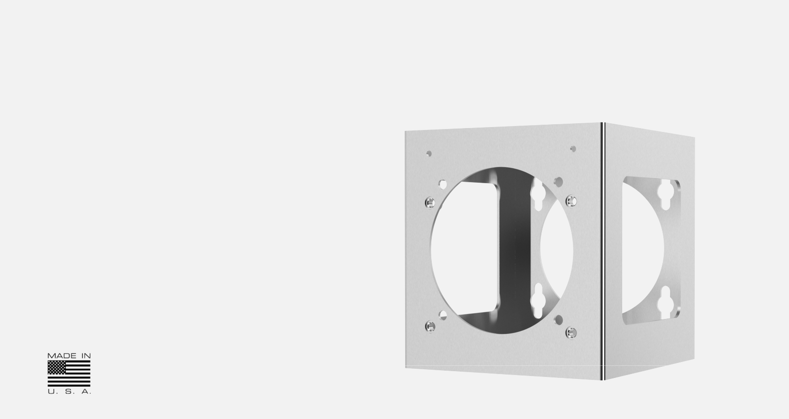
Datasheet

Spectrum SCS-UM

Universal mount

Features

• Mounts camera further away from structure

• Pendant on ceilings

• Horizontal on walls

• Stainless Steel

• For D & F-series cameras

Description

Spectrum SCS-UM universal mount allows the camera to be mounted further away from the structure, additionally the camera can be mounted horizontal on walls or pendant on ceilings.

Specifications

Dimensions | 254 x 254 x 517.525mm ( 10 x 10 x 203/8” )
Weight | 5.6kg (12.4lbs)
Material | Stainless steel
Maximum Load Tested | 1000 kg (2200lb)
Compatability | D-Series & F-Series Cameras
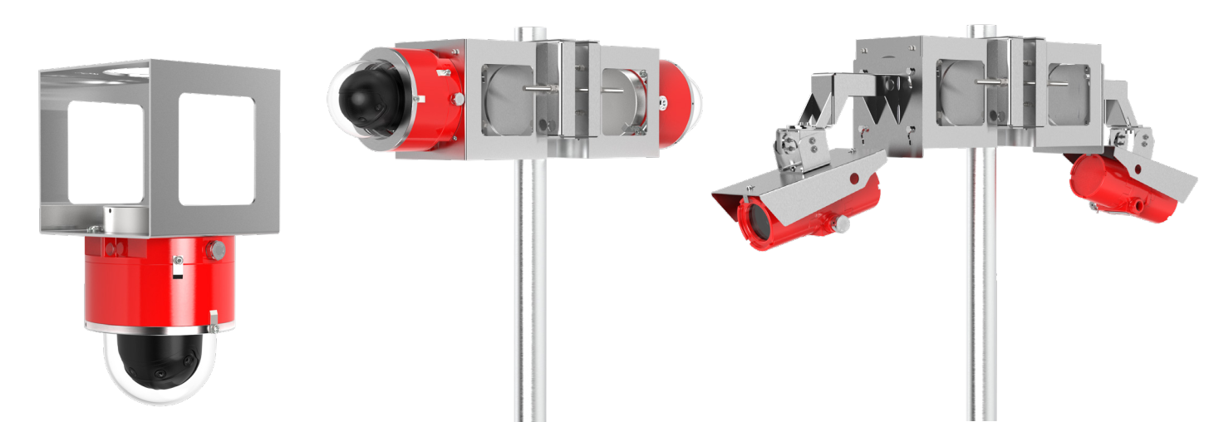

*Shown with SCS-PM pole mount *Shown with SCS-PM pole mount


Spectrum Camera Solutions | 8935 Almeda Genoa Rd. Bldg B, Houston, Texas 77075 | 281-769-8802 | sales@spectrumcamera.com www.spectrumcamera.com

DOC. SCS-UM 0822 RØ

